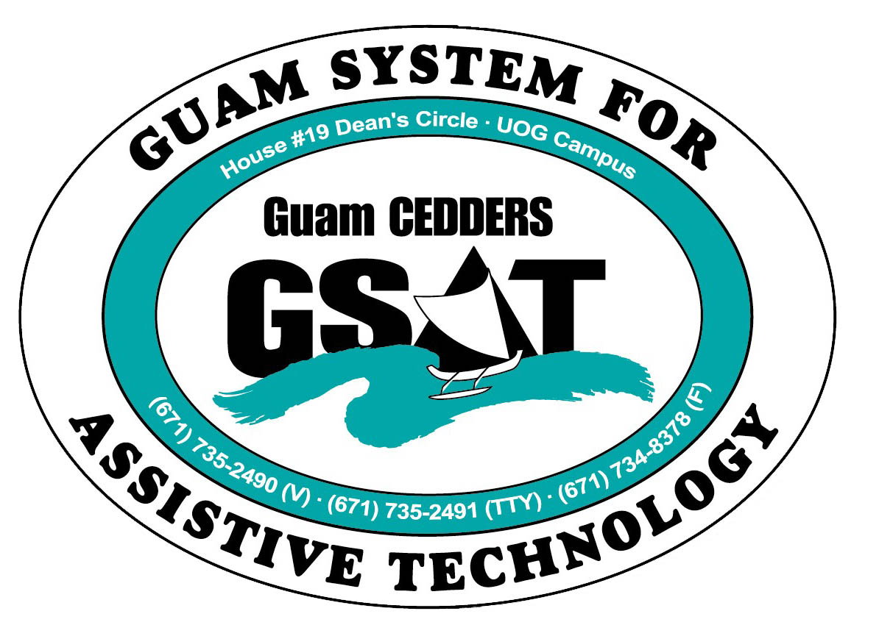
University of Guam CEDDERS
Guam System for Assistive Technology
Advisory Council
Conference/Fair Committee Meeting
Wednesday, November 8, 2011, 10:00-12:00pm
House 19 Deans Circle, UOG

(X) Lou Mesa, Chairperson (X) Carla Torres (GSAT)
(X) Josephine Cortez, Vice-Chairperson (X) Roseanne Ada (GDDC)
(X) Barbara Johnson, Secretary ( ) Marie Libria (GDDC)
(X) Noel Lazaga, Member At Large ( ) Michelle Cruz (GLSC)
(X) Hikie Lazaga, Member At Large (X) Deedee Cruz (CILG)
( ) Lisa Ogo (X) Greg Calvo (AHRD/ WIA)
( ) Bill Fuppul ( ) Frances Bell (AHRD/ WIA)
( ) Linda Leon Guerrero (X) Ben Servino (DISID/ DVR)
(X) Evelyn Duenas (via phone) (X) Kirsten Bamba (Interpreter)

Minutes
- Conference:
- Theme:
More theme ideas were added, no vote took place. Tabled for Dec.13 meeting.
- AT to the Max!
- AT: Maximizing One’s Potential
- AT: Search for Disabilities
- AT: A Vision of Needs
- AT: A Vision of Solutions, Meeting Needs and Overcoming Barriers
- AT for Work, Home, School, and the Community
- AT: Achieving Life!
- Improving or Enhancing our Quality of Life through AT
- Affordable AT
- Education of Technology
- Evolution of Assistive Technology

- Agenda- Topic ideas for sessions are as follows:
1. “Bringing Things into Focus”: This session will demonstrate solutions for magnification/ text to speech/ access to print for those with low vision or who are blind.
2. “Seating for Success”/ “The Essential Elements of a Wheelchair Assessment”: proper fit for wheelchairs is very important. Ill-fitting wheelchairs can do a lot of damage. It could also mean the difference in individuals accessing other AT.
3. “Electronic Aids to Daily Living”: EADLs can provide people with disabilities independence and safety with home tasks. There are many simple to complex ways that allow operation of entertainment systems, telephones, and other devices in the home.
4. “What are the Best Ways to Assess Uses and Impact in k-12 setting?”: an overview of assistive technology and ways to identify AT as an accommodation or adaptation. Suggestions for incorporating AT into curriculum and IEP’s as well as effective assessment procedures to determine the most appropriate AT Tools for K-12 students. How to incorporate AT into the learning curriculum, implement AT services into a student’s IEP, and understand the steps needed to properly assess assistive technology equipment as an educational enhancement tool.
5. “Have an Appetite for Apps?”: This session will look at the world of apps on the iDevices (iPhone, iPad, iTouch) and what they offer people with disabilities of all age ranges and disability types.
6. Communication solutions through low and high tech AACs: This session will look at the range of alternative augmentative communication (AAC) devices and highlight the different features offered in each.
7. Ko Sina Ha? Hugan!: Self Advocates in Actions (SinA) will share basic principles of advocacy and how they lead to rewarding lives.
8. Setting Sights on New Horizons: NVG!
9. Self-employment partnerships, examples of things in the past, highlight existing/successful businesses (DVR/LOAN programs/ SBDC/DOL), One-stop Center highlights accessibility
10. AT for ind w/ autism (AT Speaks): vast range of solutions, educating the community of what is possible
11. HH/DHH: resources available to individuals who are D/HH, captioning phones, real-time captioning, relay services (video/TRS), how to hire interpreter
12. Website access: sec. 508 (Jonas, other private web designers, BIT: what they are doing to comply)
13. low tech solutions on the fly, how to craft AT solutions from household materials
14. Exhibits of accessible/ mainstream technology (i.e. automatic toilet liners)
15. Universal design (RIM Architects)
16. Smart Pens (users to share experience)

- Menu
The “Island Menu” was voted upon.
- Fair:
- Table Displays
Working off of list from previous years
- Other events i.e. raffle, performances
Committee decided that the Superfriends live on the radio and 1 or 2 performances (singer w/ signed interpretation and/ or Joe Andersen playing guitar) will be enough entertainment. Don’t want fair to be “noisy” the entire time and distract from folks obtaining information/ visiting displays. Decided that there will be no raffle, but participants will receive a GSAT promo item upon submitting a survey. Survey will be on one side of form and the other side will contain spaces to obtain 10 signatures from vendors.

- Miscellaneous
- Timelines
- Venue Booking
Westin confirmed for March 16, proposal received; cost going to be $6,070 for 180pax. Committee will meet at the Westin on November 28 at 10AM to conduct a walkthrough/ ADA check of facility.
- Advertisements
GDDC has graciously offered to pay for 1 PDN and 2 MV newspaper print ads. Ads will run Feb.16, 24, March 11.
- Registration
Registration for Conference: done at Fair and by taking calls/ emails through GSAT, closed by March 13. Have flyers to hand out at Fair
Invites to vendors for fair displays: Jan.9, deadline to respond by Feb.3
- Collaborators/ Co-sponsors
Tri-Agency (CEDDERS, GDDC, GLSC), DISID/DVR to contribute in-kind, staff assistance, logistics, etc.; Greg stated One-Stop committed as a partner
- Others….
Plenary session should be engaging and fun. Some ideas are a skit of “The Evolution of AT/ AT Through the Years..”, Talent Show (of AT), Lisa Ehlers to play piano perhaps during lunch.

*Next meeting is scheduled for December 13 from 10AM-12PM at GSAT.

