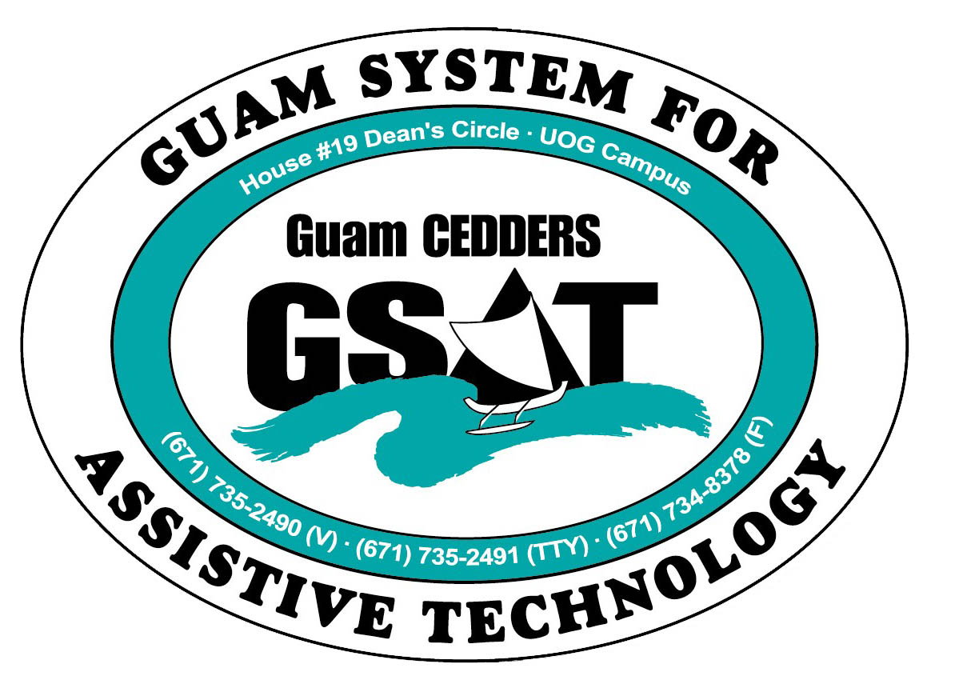
University of Guam CEDDERS
uam System for Assistive Technology
Advisory Council
General Membership Meeting
Tuesday, April 29, 2014, 3:30-5:00pm
House 19 Deans Circle, UOG
( ) Lisa Ogo, Chairperson | ( ) Tavita Faasuamalie | ( ) Carla Torres (GSAT)
( ) Evelyn Duenas, Vice-Chairperson | ( ) Bill Fuppul | ( ) Michelle Cruz (GLSC)
( ) Josephine Cortez, Secretary | ( ) Rudy Ignacio | ( ) Dawn Maka (GCIL)
( ) Vedalema Valencio, Member At Large | ( ) Steve Fuppul | ( ) Roseanne Ada (GDDC)
( ) Roy Rosario, Member At Large |  | ( ) Ben Servino (DVR/ DISID)
( ) Barbara Johnson, Member-at-Large |  | ( ) Terese Crisostomo (GDOE)
( ) Lou Mesa |  | ( ) Carina Raguinda (AHRD/ WIA)

AGENDA
- Call to Order / Introductions

- Review & Approval of Minutes
Meeting: January 22, 2014
III. Reports
- Conference/ Fair
- Survey Results
- Conference/ Fair Debrief
- Wheelchair workshop
- Survey Results
- Next Steps…Issues
- Quarterly Report

- Old Business
- Updates to House 20

- New Product
- Pediatric Wheelchair- Miana’s Story
- Purchase of Wheelchair Simulator

- Open Discussion/ Announcements
- DD Awareness Month
- PEP 5K
- DISID Computer Center- underutilized

- Adjournment

Next Meeting July 15, 2014, 3:30-5:00PM

