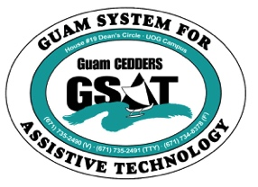
University of Guam CEDDERS
Guam System for Assistive Technology
Advisory Council
General Membership Meeting
Tuesday, October 21, 2014, 3:30-5:00pm
House 19 Deans Circle, UOG
( ) Lisa Ogo, Chairperson | ( ) Lou Mesa | ( ) Carla Torres (GSAT)
( ) Evelyn Duenas, Vice-Chairperson | ( ) Tavita Faasuamalie | ( ) Michelle Cruz (GLSC)
( ) Josephine Cortez, Secretary | ( ) Bill Fuppul | ( ) Rosanne Ada (GDDC)
( ) Vedalema Valencia, Member At Large | ( ) Rudy Ignacio | ( ) Ben Servino (DVR/ DISID)
( ) Roy Rosario, Member At Large | ( ) Steve Fuppul | ( ) Terese Crisostomo (GDOE)
( ) Barbara Johnson, Member-at-Large | ( ) Dawn Maka | ( ) Carina Raguindin (AHRD/ WIA)
 |  | ( ) Kirsten Bamba (ASL Interpreter)

AGENDA
- Call to Order / Introductions

- Review & Approval of Minutes: July 15, 2014

- New Business
- Revision of By-Laws
- New Fiscal Year
-Budget
-Calendar
-End of Fiscal Year Reporting

- Old Business
- House 20 updates
- DISID Computer Center- underutilized: updates?

- Reports:
- Lucky 13: Guam Highlight
- Quarterly Data
- New Equipment

- Election of Officers
*review By-Laws

- Committee Sign-up
- Outreach
- Ad-Hoc to Purchase Wheelchair Simulator

- Open Discussion/ Announcements

- Adjournment
Next Meeting January 20, 2015, 3:30-5:00PM

