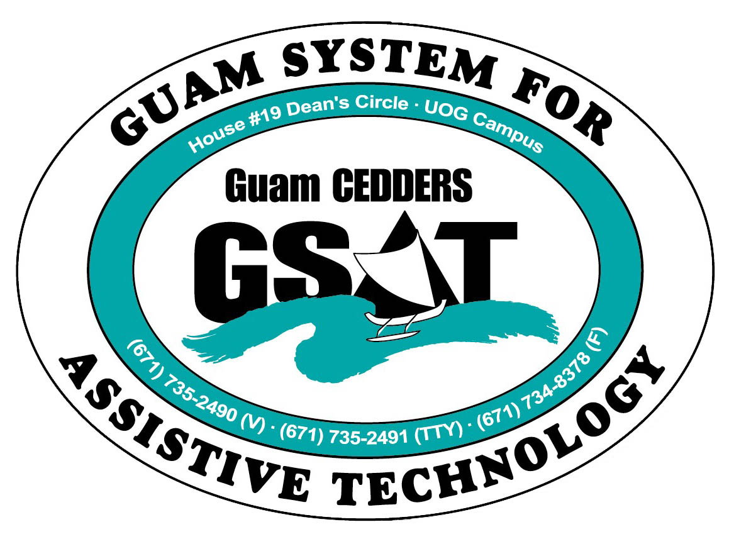
University of Guam CEDDERS
Guam System for Assistive Technology
Advisory Council
General Membership Meeting
Tuesday, October 22, 2013, 3:30-5:00pm
House 19 Deans Circle, UOG
(X) Josephine Cortez, Chairperson | (X) Roy Rosario | (X) Carla Torres (GSAT)
(X) Lisa Ogo, Vice-Chairperson | ( ) Rudy Ignacio | (X) Michelle Cruz (GLSC)
(X) Vedalema Valencio, Secretary | ( ) John Kimmons | (X) Dawn Maka (GCIL)
(X) Evelyn Duenas, Member At Large | (X) Kirstine Bamba | ( ) Roseanne Ada (GDDC)
(X) Lou Mesa, Member At Large |  | (X) Ben Servino (DVR/ DISID)
( ) Bill Fuppul, Member-at-Large |  | ( ) Terese Crisostomo (GDOE)
(X) Tavita Faasuamalie |  | (X) Carina Raguinda (AHRD/ WIA)

Minutes of the Meeting
- Call to Order / Introductions
The meeting was called to order at 3:31PM
- Review & Approval of Minutes
Lisa Ogo made a motion to approve the July 16, 2013 minutes, Dawn Maka seconded the motion. Approved by acclamation
III. New Business
- New Equipment (equipment list disseminated)
- Demo: Prodigi

- Old Business
- 2014 Conference/ Fair Committee Schedule Meeting
- Council Outreach
- Review goals
- Action Plan
  - SRC: VR State Plan, AT related goals (outreach strategy)
  - VA: Chapter 31 Vendorization
- Website Revamp

- Elections New FY 2013-2014
*review By-Laws

- 5 year impact report

- Open Discussion/ Announcements
- NDEAM, council suggestions
- White Cane Relay
- Change in meeting time

Next Meeting: January 20, 2014, 3:30-5:00pm, GSAT

Items distributed to members: 5 year impact report, GSAT promo items: bag, crayon, pen w/ highlighter, CEDDERS pocket calendar & desk strip

