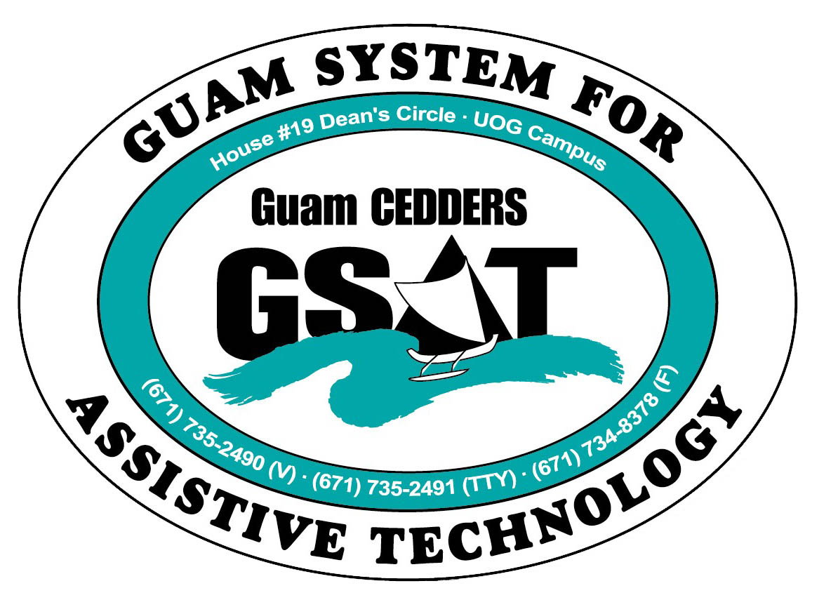
University of Guam CEDDERS
Guam System for Assistive Technology
Advisory Council
General Membership Meeting
Tuesday, October 22, 2013, 3:30-5:00pm
House 19 Deans Circle, UOG
(X) Josephine Cortez, Chairperson | (X) Roy Rosario | (X) Carla Torres (GSAT)
(X) Lisa Ogo, Vice-Chairperson | ( ) Rudy Ignacio | (X) Michelle Cruz (GLSC)
(X) Vedalema Valencio, Secretary | ( ) John Kimmons | (X) Dawn Maka (GCIL)
(X) Evelyn Duenas, Member At Large | (X) Kirsten Bamba | ( ) Rosanne Ada (GDDC)
(X) Lou Mesa, Member At Large |  | (X) Ben Servino (DVR/ DISID)
( ) Bill Fuppul, Member-at-Large |  | ( ) Terese Crisostomo (GDOE)
(X) Tavita Faasuamalie |  | (X) Carina Raguindin (AHRD/ WIA)

Minutes of the Meeting

- Call to Order / Introductions
The meeting was called to order at 3:31PM

- Review & Approval of Minutes
Lisa Ogo made a motion to approve the July 16, 2013 minutes, Dawn Maka seconded the motion. Approved by acclamation

III. New Business
- New Equipment (equipment list disseminated and discussed)
Ti-lite – not loaning out
Z-20 Videophone – The video relay service replaced the TTY’s, works through internet, and not through local telephone companies. TTYs are pretty much obsolete in use. On the publications or advertisements you will see a VRS number instead of a TTY. Federal Communications Commission will eventually identify VRS as a way of access for individuals who are deaf/hard of hearing. For now, TTYs are still required. Video relay allows for face to face communication, enabling a preferred mode of communication, sign language. Lisa Ogo asked if new equipment was ordered for the blind. Carla provides information on the Eyepal and the Smartview Versa 360 Graduate.
- Video Demo: Prodigi -newest devices on the market for low-vision, ADHD, learning disabilities, and print disabilities in general (portable video magnifier with text to speech

- Old Business
- 2014 Conference/ Fair Committee Schedule Meeting
All agreed to meet November 5, 3:00PM. Lisa suggested the morning as it’s easier for bus riders. Lou Mesa has class; Kirsten has parent-teacher conference on the 5th. The committee will work on dates and logistics. Carla proposed to have the Fair on March 1st and the Conference on the March 28. She would like to send out the Save the Dates as soon as possible. Guam Legal isn’t able to provide financial support for the Conference this year because of budget cuts but can provide support with manpower. For the past several years, they have paid half for facility rental, a significant contribution. This shouldn’t pose an issue as we are trying to spend down a carry-over year. We have adequate funds to cover the facility rental. If the Mall will charge this year, may need to look into ways to cover. Michelle Nicole asked if the new administrator at DVR could attend the Conference and Fair Committee meetings. Ben concurred.

- Council Outreach
- Review goals
Employment: Previously drafted goals reviewed. Carla hasn’t heard anything about the National Disability Employment Month (NDEAM). Ben said possibly due to the transition with the new VR Administrator. In trying to achieve the outreach to employers without using NDEAM, consider having a dedicated section for employers during the Fair in March. Ben suggests support from DVR. The second goal, to send out a newsletter to an employer listserv is in the works. The listserv is compiled.

Parents: Use-social networking, social media, brochures during parent-teacher conference, target elementary school, do multiple schools during multiple days, pass info through students, introduction at school orientations, mayor’s offices and council, make a commercial (i.e. Kuam in the Mix for free airtime, YouTube, topic specific workshops, coordinate with parent services at DOE. Carla will be presenting to a parents during a series of workshops hosted by Leone Rohr and Carol Darlow. Presentation will be on AT, supplementary aids & services,and modifications and accommodations.

- Action Plan
Employment: Since using NDEAM as an opportunity for outreach is gone, consider putting a dedicated Employment Section at the Fair. We should ask DVR to take the lead.
Newsletter –Since Carina is part of AHRD, it would be great for her to be a part of this workgroup so we can include DOL services. VR should collaborate on the newsletter too. Target dissemination will be on March 1^{st.} Michelle Nicole asked if the DOE Transition Coordinators should be a part of it too. Carla stated that we are still waiting for a new representative from DOE.

Parents: Michelle Nicole said that Guam Legal can partner up and send out information to teachers, parents. Help with display tables at parent/teacher conferences. Lou said that in middle school, they setup tables in the hallway, where they pass out the report cards before heading into the room. Michelle Nicole suggested partnering up with Masters in Special Education Program at UOG. And further added that we could have one or two of the students go out and give information. Carla is not sure if program still exists and will look into it. Kirsten announced a Deaf Class at GCC where elementary and middle school students come over as a fieldtrip. Kirsten could do ASL activities and presentations on GSAT/ AT and provide info to parents. (Carla provided her with some brochures)

When the executive committee met, Lou suggested that Carla be a part of the State Rehabilitation Council (SRC) because the VR State Plan has AT Related Goals. Carla is awaiting nomination. (VR State Plan disseminated, AT areas highlighted, and discussed.)

VA: Chapter 31 Vendorization
Carla met with the Veterans Affairs’ Vocational Rehabilitation Counselor, Ashley Morton to discuss Chapter 31 Vendorization. Becoming a Chapter 31 vendor would allow the VA to pay GSAT to provide AT evaluations and training to veterans on island and in the region. The VA can pay for AT Training and AT itself, but they don’t pay for AT assessments. Rather, they work with the local VR Agencies to cover AT assessments. VA is working Frank Pangelinan at VR on an MOU. GSAT has yet to get an MOU with VR. Ashley Morton will relocate to Hawaii next month, but she provided her with the Supervisor’s contact info. She set a goal that before she leaves the island, the MOU with VR and GSAT and our application will be done.

- Website Revamp (sample shown on screen)
Not ready to be launch, overall affect good but still working on content.

- Elections New FY 2013-2014 (Reviewed by-laws)

Eligible members to vote are the following:
- Josie Cortez | - Roy Rosario
- Lisa Ogo | - Vedalema Valencia
- Lou Mesa | - Michelle Nicole Cruz
- Evelyn Duenas | - Rosanne Ada

Lou Mesa inquired if the Vice Chairperson gets rolled over to Chairperson and if they have the option to decline. Carla mentioned of course, they could, would never force into a position. This practice is not indicated in the by-laws but that this was the practice Carla came into and suggested getting it written into the by-laws. Ben stated the reason for that is it builds capacity.

Lisa accepted the role as chairperson.
Barbara nominated Evelyn for Vice-Chairperson, Evelyn accepts
Lisa Ogo nominated Lou Mesa for Vice-Chairperson, Lou declines
Lisa Ogo nominates Josie Cortez for Secretary, Josie accepts
Roy nominates himself for Member-at-Large
Velmarie nominates Vedalema for Member-at-Large, Vedalema accepts.
Josie nominates Barbara for Member at Large, Barbara accepts

All accepted nominations are running unopposed, thereby no votes are necessary

2013-2014 GSAT Officers
Chairperson: Lisa Ogo
Vice-Chairperson: Evelyn Duenas
Secretary: Josie Cortez
Member-at-Large: Roy Rosario
Member at Large: Vedalema Valencia
Member-at-Large: Barbara Johnson

- Open Discussion/ Announcements
(Items distributed to members: 5 year impact report, GSAT promo items: bag, crayon, pen w/ highlighter, CEDDERS pocket calendar & desk strip)
Kirsten Bamba shared an ASL Flash mob they did at GPO (video shown). Signed songs and stories were presented at some elementary schools. Lou Mesa announced that the Autism Community Together changed the General Membership Meeting from the first Saturday of each month to the last Saturday. Ben said the Down syndrome Meeting is this coming Sunday, October 27, at 10 a.m.
- Adjournment
Meeting adjourned at 5:04 p.m.
Next Meeting: January 20, 2014, 3:30-5:00pm, GSAT

