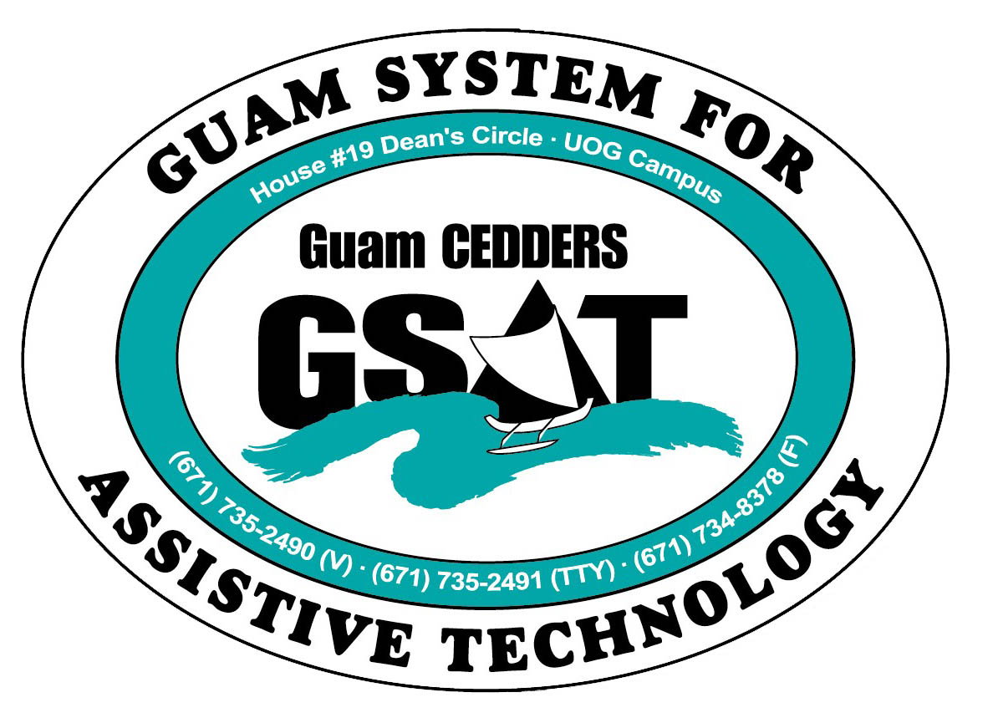
University of Guam CEDDERS
Guam System for Assistive Technology
Advisory Council
General Membership Meeting
Tuesday, April 21, 2015, 3:30-5:00pm
House 19 Deans Circle, UOG
( ) Rudy Ignacio, Chairperson | ( ) Evelyn Duenas |  | ( ) Carla Torres (GSAT)
( ) Dawn Maka, Vice-Chairperson | ( ) Lou Mesa |  | ( ) Michelle Cruz (GLSC)
( ) Josephine Cortez, Secretary | ( ) Steve Fuppul |  | ( ) Roseanne Ada (GDDC)
( ) Vedalema Valencia, Member At Large |  | ( ) Lisa Ogo |  | ( ) Ben Servino (DVR/ DISID)
( ) Barbara Johnson, Member At Large | ( ) Roy Rosario |  |  | ( ) Paula Ulloa (GDOE)
( ) Tavita Faasuamalie, Member-at-Large |  |  |  | ( ) Tilda Meno (AHRD/ WIA)

AGENDA
- Call to Order / Introductions

- Review & Approval of Minutes: January 27, 2015

- New Business
- Training: Transition into Community Living
- Transfer of AT Grant to HSS

- AT Fair Debrief
- Survey results
- Council feedback

- AT Conference Debrief
- Survey results
- Council feedback

- Reports:
- Quarterly data
- Equipment purchases

- Open Discussion/ Announcements

- Adjournment
Next Meeting July 21, 2015, 3:30-5:00PM

