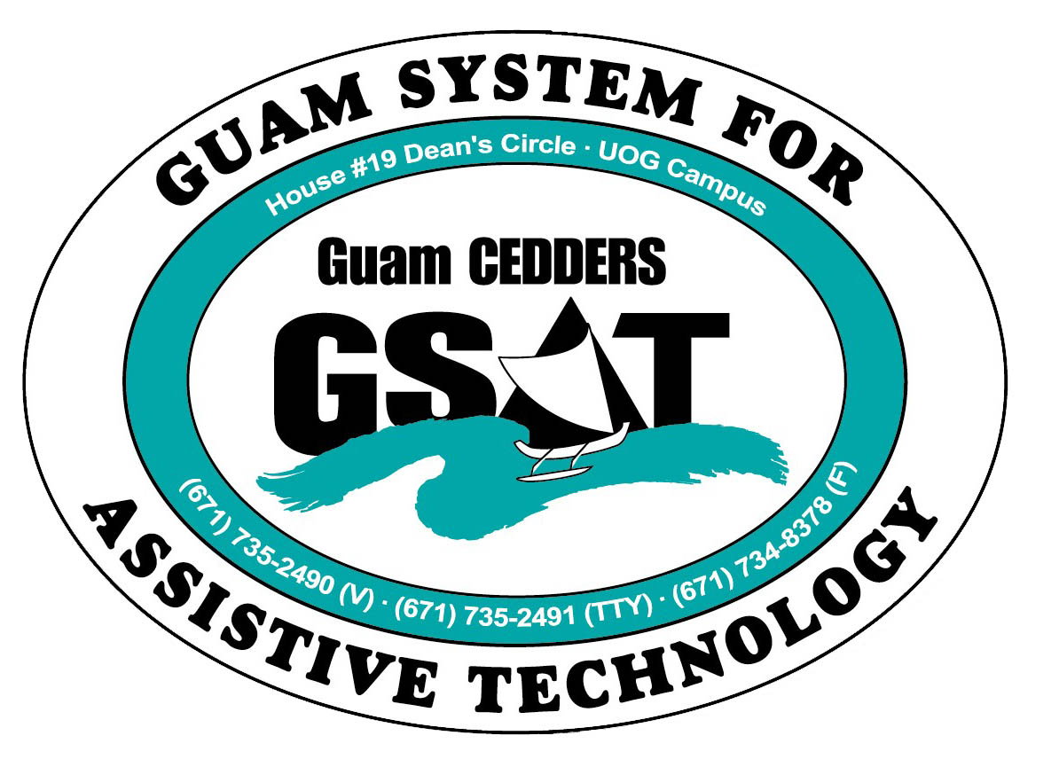
University of Guam CEDDERS
Guam System for Assistive Technology
Advisory Council
General Membership Meeting
Tuesday, April 21, 2015, 3:30-5:00pm
House 19 Deans Circle, UOG
 | ( ) Rudy Ignacio, Chairperson |  | (X) Evelyn Duenas |  | (X) Carla Torres (GSAT)
 | (X) Dawn Maka, Vice-Chairperson |  | (X) Lou Mesa |  | (X) Michelle Cruz (GLSC)
 | (X) Josephine Cortez, Secretary |  | ( ) Steve Fuppul |  | (X) Roseanne Ada (GDDC)
 | (X) Vedalema Valencia, Member At Large |  |  | (X) Lisa Ogo |  | (X) Ben Servino (DVR/ DISID-DSS)
 | (X) Barbara Johnson, Member At Large |  | (X) Roy Rosario |  |  | (X) Paula Ulloa (GDOE)
 | ( ) Tavita Faasuamalie, Member-at-Large |  |  |  |  | ( ) Tilda Meno (AHRD/ WIA)
 |  |  |  |  | (X) Kirsten Bamba (ASL Interpreter)

Minutes of the Meeting

- Call to Order / Introductions
Dawn Maka called the meeting to order at 3:36p.m. Attendance was noted.

- Review & Approval of Minutes: January 27, 2015
Lisa Ogo makes a motion to approve the minutes with corrections made to Ben Servino’s agency name to include DSS. Josie seconds the motions. All in favor by acclamation
- New Business
- Training: Transition into Community Living
Carla said she budgeted to hold transition training for July. Target Audience are to include individuals that are at Skilled Nursing Unit (SNU) transitioning back into home life and those that are in assisted living program migrating back into the family. In response to Rosanne Ada’s question as to who will be the target providers, Carla said that it will be service providers and family, the Community Habilitation Programs, and students transitioning out of high school and are on employment tracks. Carla received requests from social workers that are on these group homes run by catholic social services. They have goals to integrate back into the family. Carla is looking at what assistive technology supports can be utilized to help with transition. Ben shares that Senator Rodriguez is chairing the Seniors, but also including people with disabilities. Carla mentioned speaking with Ginger about the No Wrong Door Grant with DPHSS. Rosanne Ada proposed including respite care in nursing services. In an effort to include students as target audience, Carla asked Paula if she could think of students in the postsecondary that are on an employment track , severe students. Budget for the training is at $6000. This includes facility rental and materials. Carla is considering to do the training with service providers in two days. She recommends a planning committee and will send out an email to the council.
- Transfer of AT Grant to HHS
GSAT was with the US DOE Rehab Service and Administration Grant and now moved to the Health and Human Services Administration of Community Living Grant. The funds have been frozen. GSAT did an early draw down up until May 8. On May 8 GSAT gets issued the remaining of the grant award and it will be no longer under US DOE. There are no specifics as to how things are done other than fiscal management.
- AT Fair Debrief
- Survey results. Printed copies disseminated to the Council
- Council feedback
Roy said the fair was good but it wasn’t that much people . Paula states that every year is great, they were able to share some new DHH and vision devices. There were 2 new vendors at the Fair. This includes ENJ Distributors, developers of Gumchucks, a products that supposed to makes it easier for people with physical disabilities to floss their teeth and Happy hands who did sign stories for children.. Roy suggested keeping the layout the same but toGSAT’s table. Carla said the accessibility of how the table were laid out worked well. She added that signed songs are always a hit. Carla shared that, occupational and physical therapists from Japan stopped by GSAT’s table and they were amazed by the technology. Carla gave them the website of AT vendors, to look into getting things for their patients. Ben suggested for next year including companies in Guam that sells the lifts. Ben sates that a company from Australia does it for housing. Carla requested the name of the vendor. She added that the only company that sold stair lifts is Otis elevators and Otis one time gave a client a quote of $100,000, when she found acorn lifts on a commercial for $1,500. Carla contacted acorn and the issue was not having an authorized vendor representative here who can do installations. Ben asked about the nationality portion of the survey. Carla explains that these were the things people have written in , added that we follow what’s on NIRS, data for the core grant

- AT Conference Debrief. Printed copies disseminated to the Council
- Survey results. Printed copies disseminated to the Council
- Council feedback. Carla states that it was a very successful conference. It was a lot smaller than typically planned, but the learning was more impacting and more personal. Collaborating with DOE and having the workshops got a lot of good feedback. Michelle Nicole Cruz gave credit to Paula. Carla shares feedback from an individual from CNMI who works in Protection and Advocacy. He said it was eye opening for him to see how to make low tech AT and how effective it can be. Some items that was made during the event, had the intent to donate it back when nobody was going to use it. Tom Manglona had expressed that it was too low tech for him that he was hoping to see higher tech. He attended Carla’s workshop where he built the battery interrupters and switch. He wanted to place a strobe light on his wheelchair. Carla mentioned it was the same principle to adapt his wheelchair. He ended up getting some of the concept applicable to him
Keynote Speaker. Lisa expressed that she enjoyed Maria’s story. Carla said her story was indicative of living life after an onset of a disability with AT making it happen , and the number of resources that were pulled in to make things happen for her.
- Reports:
- Quarterly data . A printed report was given to the Council to review.
No loan applications were received. Carla requested the Council to spread the word
Paula asked how we can get the word out about the AT financial loan program. Evelyn suggested providing one to one education in explaining the process . Carla shares, marketing was done with the durable medical equipment vendors. GSAT has provided an 11 x 17 poster and a GOAL-AT brochures on an acrylic stand to the vendors. She states that durable medical equipment vendors were informed that if insurance only covers 80 % , GSAT can finance the 20% . If they have no insurance, GOAL-AT is a funding source for financing. Authorized representatives or guardians can also apply for the loan. Carla cited some examples of instances when loan can be used. She discussed the loan program during parent trainings and emails She adds that the interest rate is 2.125%. Michelle Nicole Cruz proposed to partner up and do a presentation to send out to the Chamber of Commerce and employers. Carla added that besides AT , accessible vehicles and home modifications are also included in these loans . Bank of Guam is the lending institution. Decisions are decided by a Loan review committee that is comprised of individuals with disabilities. Michelle Nicole Cruz suggested creating a flyer and sending it out to the mass. Ben offered to include this information during the Conference on Entrepreneurship and Employment that DISID/DVR is co-sponsoring.
Carla explains the two loan programs: GOAL-AT and GGT, she adds that sometimes clients will qualify DVR services, but DVR won’t fund everything, we’ve done that where we cost share.
Equipment purchases. Carla said GSAT is waiting on $5000 worth of equipment to arrive. This includes the new embosser and an updated Braille translation software that produces Unified English Braille. Carla said GSAT will be starting to Braille in UEB. Paula asked if training will be done. Carla said staff gets self-trained. Carla asked the Council suggestions for what equipment they would like purchased and added to the inventory. $30,000 of the grant is considered to be budget for every fiscal year.
RESNA Conference. Carla will be attending the RESNA Conference in June at Denver, Colorado. She is doing a Pre conference workshop on 3D. Carla shares information on the Orcam. The product is available to the Continental US. You pay and then they build , but they are two years out of manufacturing , so they had orders two years in the making. For Guam, they have to have an authorized representative sales representative, trainer, and technician. The manufacturer will keep us on the loop when they’re ready to make their way to Asia.
Free Money Readers. Bureau of Printing and Engraving are issuing out free money readers. The link to the website has been emailed to the Council and individuals with a visual impairment can download the application forms and turn it in.

- Open Discussions
- Ben Servino announced that Senator Underwood had introduced the Bill 70-33 to establish a registry for people with disabilities . The purpose of the registry is to interface data information about certain people with disabilities. When police officers and first responders encounter and individual , they know what their accommodation needs , communication needs are. ID cards will be issued. This will be maintained and housed at DISID. They will look at the system, so they can expand it and the usability of it. On another note, Ben Servino is inviting organizations to partner with DISID to start developing plans for the National Employment Awareness Month. Proposed dates are October 20 or October 29.
- Kirsten Bamba informed the Council of the Deaf Self Awareness Week. On Friday May 1st will be a wave in Tamuning , right by the tennis court, on the sidewalk. Meetup is at the Tamuning Mayor’s office at 5:15 a.m. They will do some of their sign language songs. A mini expo will be held on Saturday from 10-2PM. Performance, technology from GSAT, and A deaf weaver will be present. One room will include table display and another for what they have for children. The picnic will be on May 3rd from 2PM to sunset. The movie “Hammer” with subtitles will be showing. The reason for the events is that the Deaf community has experienced a lot of disparities. Kirsten shares experience with deaf individuals at the Emergency room. She noted that a group called CLASP (Cultural Language Access Service Partners) has been formulated to try and change the barriers.
- Ben Servino met with the Guam Fire Department (GFD) and received notice that they’ve established their RFP to immigrate to text. He further states that it hasn’t come out yet. GFD is working with GSA to get with that. Carla recommends updating their equipment because their system won’t allow it.
Ben encouraged the Council to email him if they are encountering problems, issues or challenges with an agency. He meets with ADA coordinators from all the agencies and can bring this to their attention.
- Carla announced that she received a phone call and a resignation letter from Tavita Faasuamalie. He had to resign from the GSAT Advisory Council due to personal reasons. Nominations for Member at Large will be tabled to the next meeting.
- Ben Servino will be attending National ADA Conference in Atlanta on May. He states that the PacRim Conference will be held the following week, of which a seminar for students that are hard of hearing is also to take place. They will be addressing and developing a plan of action for all the jurisdictions that includes, Samoa, CNMI , and Guam
- Carla announced that Attorney Alicia Limtiaco from US Attorney Office requested to meet with her about a Workforce Development Training they plan for June. Carla will be unable to attend the training.
- Lisa Ogo requested clarification if persons with placards can park on van accessible parking lots at the Mangilao night market. Ben states that anyone who has a placard can park there, the reason why it’s different is you have more room for lifts. Ben is trying to encourage businesses to use the 11’ wide parking stall and 5’ wide access out that way cars don’t park there.
- Kirsten Bamba shared that GPO now has available 8 closed caption glasses.
- Liberation Day will be on July 21st so next meeting will be moved to July 28, 2015 from 3:30-5:00 PM.

- Adjourment

The meeting was adjourned at 4:45 p.m...

