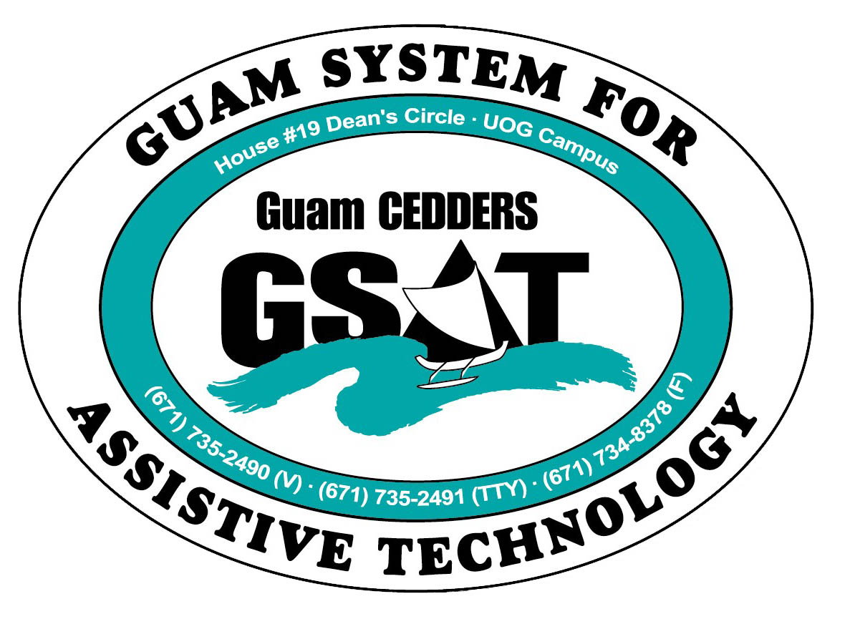
University of Guam CEDDERS
Guam System for Assistive Technology
Advisory Council
General Membership Meeting
Tuesday, July 28, 2015, 3:30-5:00pm
House 19 Deans Circle, UOG
( ) Rudy Ignacio, Chairperson | ( ) Evelyn Duenas | ( ) Carla Torres (GSAT)
( ) Dawn Maka, Vice-Chairperson | ( ) Lou Mesa | ( ) Michelle Cruz (GLSC)
( ) Josephine Cortez, Secretary | ( ) Lisa Ogo | ( ) Roseanne Ada (GDDC)
( ) Vedalema Valencia, Member at Large | ( ) Roy Rosario | ( ) Ben Servino (DISID/DVR&DSS)
( ) Barbara Johnson, Member at Large |  | ( ) Paula Ulloa (GDOE)
( ) ______________, Member at Large |  | ( ) Tilda Meno (AHRD/ WIA)

AGENDA
- Call to Order / Introductions

- Review & Approval of Minutes: April 21, 2015

- Election of Member at Large

- Transition Training (Community Living)
- Agenda
- GSAT Advisory Council Resolution on CL

- Reports:
- Quarterly data
- Equipment purchases
- RESNA Conference

- Revision of By-laws

- Open Discussion/ Announcements

- Adjournment
Next Meeting October 20, 2015, 3:30-5:00PM

