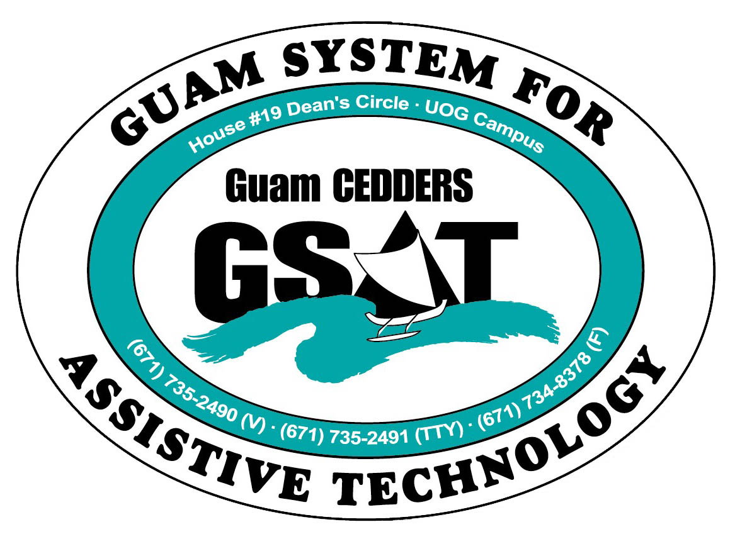
University of Guam CEDDERS
Guam System for Assistive Technology
Advisory Council
General Membership Meeting
Tuesday, July 28, 2015, 3:30-5:00pm
House 19 Deans Circle, UOG
(X) Rudy Ignacio, Chairperson | ( ) Evelyn Duenas | (X) Carla Torres (GSAT)
( ) Dawn Maka, Vice-Chairperson | (X) Lou Mesa | (X) Michelle Cruz (GLSC)
(X) Josephine Cortez, Secretary | ( ) Lisa Ogo | ( ) Roseanne Ada (GDDC)
( ) Vedalema Valencia, Member at Large | ( ) Roy Rosario | ( ) Ben Servino (DISID/DVR&DSS)
(X) Barbara Johnson, Member at Large | (X) Andrea Glymph | ( ) Paula Ulloa (GDOE)
( ) ______________, Member at Large |  | ( ) Tilda Meno (AHRD/ WIA)  (X) Kirsten Bamba

Minutes of the Meeting

- Call to Order / Introductions
Meeting called to order at 3:27PM. Carla welcomed Vicky (Andrea) Glymph who is considering joining the council. She is an individual who is deaf.

- Review and Approval of Minutes
Minutes from April 21, 2015, were reviewed for approval. Rudy Ignacio made a motion to approve the minutes. Josephine Cortez seconded the motion. Approved by acclamation.

- Election of Member at Large
Carla reminded the council that Tavita Faasuamalie resigned as member at large due to medical reasons. The election of a member at large was tabled for next meeting. Carla requested the council to invite individuals who may be interested in joining the Council.

- Transition Training (Community Living)
- Agenda. A draft agenda of the Transition Training was disseminated and reviewed. Majority of the training will cover AT to support community living. Participants will receive a resource guide that includes pictures and descriptions of the AT presented. It will also be available electronically. Ginger Porter will speak on a national initiative called “No Wrong Door” designed to streamline services for seniors and adults with disabilities. To finish the afternoon, a community resource panel will talk for 10-15 minutes each on services they provide to the community. They include Michelle Cruz of Guam Legal Services Corporation, Andrew Tydingco from Sina, Sam Illesugum from Guma’ Mami, Kim Dunlap of the Health Services of the Pacific , a Representative from Catholic Social Services , and Ben Servino of DISID. A Transition Book, done by the LEND Cohorts, will be distributed as another resource for participants. Barbara asked about AT for the deaf in the resource guide. Carla explained the book is categorized by functional needs as opposed to disability, but it does contain devices that could benefit the deaf and hard of hearing. Barbara suggested we talk to GHURA as she has been asking GHURA for accommodations to no avail. Carla said these are good issues for SINA to tackle as an organization of advocacy. Carla invited GHURA to discuss housing options for individuals with disabilities, but they are involved in a training all week that week and are not available. Michelle Cruz said if Barbara is going to agencies, asking for certain accommodations and they’re not being responsive, she can seek assistance from Guam Legal Services. She adds that a complaint does not necessarily have to be filed, writing a letter on a law office letterhead to advocate may just get them to take action. Carla provided Barbara information for Alice James who coordinates a program specifically for individuals with disabilities in GHURA homes called the Resident Opportunity Self Sufficiency (ROSS).
- GSAT Advisory Council Resolution on CL. Carla proposed a GSAT Advisory Council resolution that states its position on choice, assistive technology, and community living (a borrowed idea from TASH) that could be read at the beginning of the Transition Conference, by the members. Carla read the draft and requested the Council’s input. Lou Mesa stated that based on her own experience and parents of children with Autism Spectrum Disorder, they hope to have their kids choose where they want to live and not necessarily just place them in group homes such as having them stay at a house which they are most familiar and be provided with needed supports there. Rudy shared that he applied for GHURA and requested housing in Dededo where his family lives. He was only given an option for Merizo or Agat. It left him with no choice but to stay in Agat. He goes back and forth from Dededo to Agat and sometimes gets a denied ride because there is no bus going there. Barbara shares that in the states, interpreters are almost like parents. They teach them life skills and are grouped within dorm settings. Lou Mesa moves to approve and adopt the resolution as is. Rudy seconds the motion. All in favor.

- Reports:
- Quarterly data. A printed report was disseminated and reviewed.
- Equipment purchases. A list of equipment purchases was disseminated and reviewed. Carla highlighted the donation of a powerwheel from Miana Catahay’s parents. Her dad modified the toy, adding a switch so Miana could drive with her hands. Carla hopes to show this adapted toy to the presentation next week for Daycare providers and states that it would be a good toy for kids who can’t use their legs.

- RESNA Conference. Carla attended the Rehabilitation Engineering & Assistive Technology Society of North America (RESNA) Conference in Denver, Colorado. She shared 3D printing and the implications for Assistive Technology i.e. printing robotic hands for children.

- Revision of By-laws
Carla will work on the GSAT Advisory Council By-Laws for the council to review and work on.

- Open Discussion/ Announcements
- Michelle Nicole Cruz announced that Guam Legal Services is selling Macy’s discount coupons. She also states that Attorney Matt Wolff has resigned from Guam Legal Services.
- Barbara Johnson said that GTA is no longer using 711 relay service. Carla expressed that Video Relay is the preferred method of the current population of individuals who are deaf and hard of hearing, however TTY/ voice-text relay (711) is still the current FCC standard. GTA is out of compliance with federal law if they do not provide it.
- Lou Mesa stated Guma Mami is sponsoring a Photo Voice project called Na’sanao I Patgon Hu!, a photography workshop that started yesterday. It focuses on a life of a care provider and parent of a person with the disability. They have 10 open slots. Victor Consaga of UOG conducts classes on Mondays and Wednesdays from 4-6PM. They’re going to host an exhibit in September. Lou will keep posted on venue. She also announced that The Creative Arts Spirit will be August 14 from 6-9PM at the Infinity Gallery, Nissan.
- Carla announced that on October 29 &30, SBDC, DVR, and GGT is sponsoring a Self-Employment Conference for individuals with disabilities.

- Adjournment
Meeting adjourned at 4:21PM

