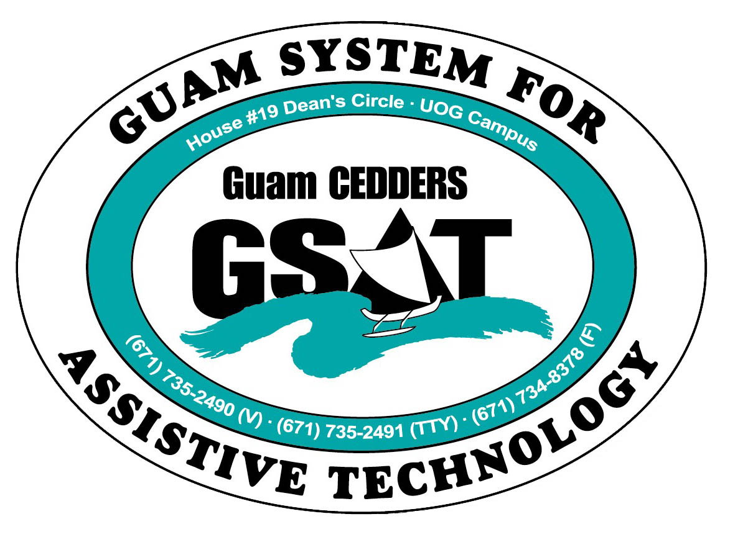
University of Guam CEDDERS
Guam System for Assistive Technology
Advisory Council
General Membership Meeting
Tuesday, October 27, 2015, 3:30-5:00pm
House 19 Deans Circle, UOG
( ) Rudy Ignacio, Chairperson | ( ) Evelyn Duenas | ( ) Carla Torres (GSAT)
( ) Dawn Maka, Vice-Chairperson | ( ) Lou Mesa | ( )_________________ (GLSC)
( ) Josephine Cortez, Secretary | ( ) Lisa Ogo | ( ) Roseanne Ada (GDDC)
( ) Vedalema Valencia, Member at Large | ( ) Roy Rosario | ( ) Ben Servino (DISID/DVR&DSS)
( ) Barbara Johnson, Member at Large |  | ( ) Paula Ulloa (GDOE)
( ) ______________, Member at Large |  | ( ) Tilda Meno (AHRD/ WIA)

AGENDA
- Call to Order / Introductions

- Review & Approval of Minutes: July 28, 2015

- Update Council Binders- Yearly Calendar, etc.

- Transition into Community Living Conference feedback

- Reports
- Quarterly Data
- House 20- New AT Demo Center

- Revision of By-laws

- Election of New Officers

- Open Discussion/ Announcements

- Visit new Demo Center

- Adjournment
Next Meeting January 18, 2016, 3:30-5:00PM

