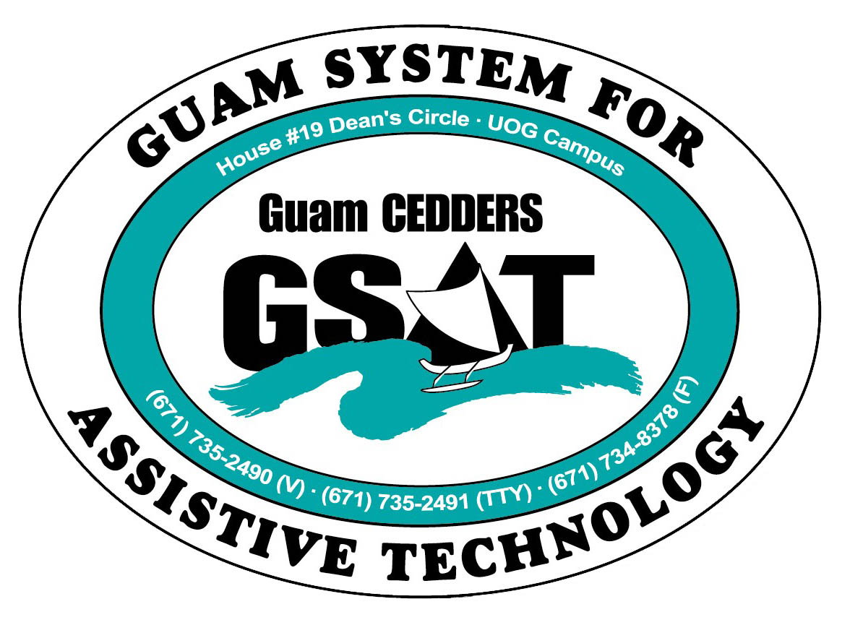

University of Guam CEDDERS

Guam System for Assistive Technology

Advisory Council

General Membership Meeting

Tuesday, April 19, 2016, 3:30-5:00pm

House 19 Deans Circle, UOG
(X) Barbara Johnson, Chairperson | (X) Josephine Cortez | (X) Carla Torres (GSAT)
(X) Rudy Ignacio, Vice-Chairperson | ( ) Evelyn Duenas | (X) Jennifer Vicente (GLSC-DLC)
( ) Dawn Maka, Secretary | ( ) Lee Perez | ( ) Roseanne Ada (GDDC)
(X) Lisa Ogo, Member At Large |  | (X) Ben Servino (DISID DVR/DSS)
(X) Roy Rosario, Member At Large |  | ( ) Nichol Napoleon (GDOE)
(X) Lou Mesa, Member-at-Large |  | ( ) Karen Taitano Primacio (DOL AJC, WIA)
 |  | (X) Evangelis Babauta
Minutes of the Meeting

- Call to Order / Introductions
Rudy Ignacio, called the meeting to order at 3:40PM, followed by attendance. Rudy conducted the meeting in Barbara’s absence.

- Review & Approval of Minutes:
Lisa makes a motion to approve the minutes, with correction on the Agenda to show January 19, 2016. Lou seconds the motion. All in favor.

- Revision of Bylaws- Sections IV-VII
The Executive Committee met and drafted updates to sections IV-VII. Carla presented the draft for review and discussion. Updates adopted are as follows:

Section IV - Officers. 3 members-at-large will be included as officers. Under the duties of the Secretary, the Council agrees to change “and all GSAT functions” to “at all GSAT functions.” Carla also made the clarification that the “responsibility of the inclusion and participation of Council members at GSAT functions” is not the responsibility of the Secretary but the program staff, ensuring appropriate accommodations are provided.

Section V-B Committees. Lou Mesa proposed to require at least 3 executive committee members on committees with other appropriate persons appointed by the Chairperson in consultation with the program coordinator. Lisa and Roy expressed agreement, whole council agreed. Change made from 1 executive committee member to three (3) executive members on committees. Carla pointed out that the one committee member requirement was in the previous bylaws, but majority of the executive committee and council members have participated in committees.
Section VI. Meetings. A quorum is established if 4 members who are individuals with disabilities and/or their family members. The AT Act states that the Council is “consumer-driven,” hence the quorum is generated from this population. Notice of the quarterly meetings, are calendared at the beginning of the fiscal year, posted on the GSAT and CEDDERS website, and announced during the meetings. Lou Mesa asked if a meeting with quorum can be held without the GSAT coordinator. Carla responded that it’s important and indicated in the bylaws that a GSAT coordinator or GSAT staff is present as the council is an advisory capacity. If the program coordinator is off-island or on an extended leave of absence, a CEDDERS staff will be assigned and in the acting capacity of the program coordinator, and will attend the meeting.

Lisa Ogo makes a motion to adopt the remaining sections IV-VII of the revised bylaws. Roy seconds the motion. All in favor.

- 2016 AT Conference/Fair Debrief ( copies of the surveys were disseminated)
Carla requested direct input from the council for next year’s planning.
Conference:
  - Keep it plenary. Participants leaving early is a reason for the small number of surveys being collected. Lisa recommended an invite list selective to individuals with specific needs addressed by the conference. Council discussed how situations vary for individuals needing to leave early like transportation. JFK students had to leave early too to catch the school bus home. Option could be to have better coverage of the doors and ask participants to fill out the surveys before leaving or emailing the survey forms out after the event.
  - Move conference to a “Saturday” so more people could be involved.
  - Suggest participants pay a small amount like $5 so they have a vested interest. *Might be hard for service providers who are normally given administrative leave to make it on the weekends. They may also find the payment difficult with procurement regulations or funding.
  - Require participants to sign in the morning and after lunch.
  - Lisa requested to have venue again at the Westin
Fair (Concourse 3 of the Mall)
- Acoustics echoed
- People who attended was there for the information
- Not a lot of people were aware of the Fair
- Schedule with the mall way in advance of the Easter season

- Quarterly Data Report: Jan.1-Mar.31, 2016 (report disseminated)
Key things discussed under the Public Awareness Activities was the 5 part series on KUAM’s primetime for the Developmental Disabilities Awareness month. GSAT had 3 slots, GLSC and GDDC each had one. Because Maria Bontogon’s series informational, the news reporter decided to give it a two part series on their Healthy Living Show. The Post did an article on the AT center and as result, it received international attention on HMEA Inc.‘s Facebook page.

- KUAM Primetime Outreach
Carla announced that In the Mix host and producer, Joan Charfauros, is sending out an open invitation to KUAM’s Healthy Living Program. Roy is interested in featuring a device demonstration.

- Open Discussion/ Announcement
- May 7-Better Speech & Hearing Month Fair hosted by Marianas Alliance of Speech Hearing Professionals, 10am-2PM, Micronesia Mall. Council can volunteer to help display/ demo
- Ben Servino announced that the ADA Anniversary will be in July. A date has not been decided. A planning meeting will be scheduled for the month’s activities. Ben shared that the Hagatna swimming pool opens today, the director assured a lift will be installed. Additionally, the San Diego State University applied for a grant to take over the ADA technical center. If they get the grant, they’re going to allocate funds to hire someone in Guam to serve as a liason. Ben shared that also in July, there is an international celebration in the Pacific Basin of the rehabilitation for individuals with disabilities. The Counsel General of the Philippines wants to partner with Guam. On another note, Ben is recruiting members for the State Rehabilitation Council, State Independent Living Council under the Division of Vocational Rehabilitation, and the DISID Council. People who are not participating in other councils are preferred. A meeting will be held on Thursday to go over the Workforce Innovation and Opportunity Act (WIOA) State Plan.
- Lisa ogo asked about monkeys as service animals. Ben stated that ADA definition for service animals is only dogs and miniature horses. She also shared about an app similar to Uber called Stroll Guam. She states that it is a taxi service that cost $1.25/mile. It was featured in KUAM and PDN.

- Adjournment

The meeting was adjourned at 4:57PM.

Next Meeting: July 19, 2016, 3:30-5:00PM

