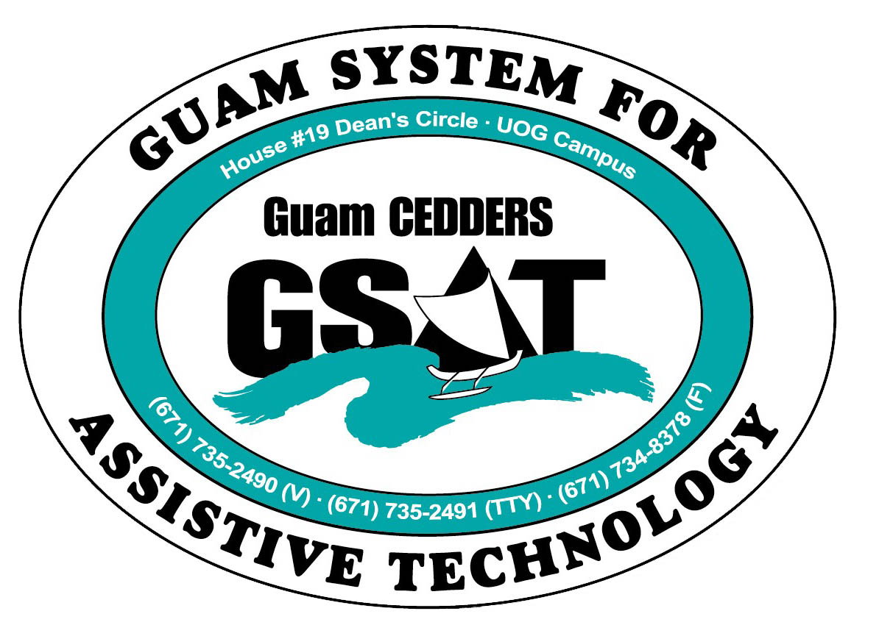

University of Guam CEDDERS

Guam System for Assistive Technology

Advisory Council

General Membership Meeting

Tuesday, April 19, 2016, 3:30-5:00pm

House 19 Deans Circle, UOG
( ) Barbara Johnson, Chairperson | ( ) Josephine Cortez | ( ) Carla Torres (GSAT)
( ) Rudy Ignacio, Vice-Chairperson | ( ) Evelyn Duenas | ( ) Jennifer Vicente (GLSC)
( ) Dawn Maka, Secretary | ( ) Lee Perez | ( ) Roseanne Ada (GDDC)
( ) Lisa Ogo, Member At Large |  | ( ) Ben Servino (DISID DVR/DSS)
( ) Roy Rosario, Member At Large |  | ( ) Nichol Napoleon (GDOE)
( ) Lou Mesa, Member-at-Large |  | ( ) Karen Taitano Primacio (DOL AJC, WIA)

  - AGENDA
- Call to Order / Introductions

- Review & Approval of Minutes: January 27, 2016

- Revision of Bylaws- Sections IV-VII

- 2016 AT Conference/Fair Debrief

- Quarterly Data Report: Jan.1-Mar.31, 2016

- KUAM Primetime Outreach

- Open Discussion/ Announcement
- May 7-Better Speech & Hearing Month Fair(DOE SpEd), 10am-2PM, Micronesia Mall
*Council can volunteer to help display/ demo

- Adjournment

Next Meeting: July 19, 2016, 3:30-5:00PM

