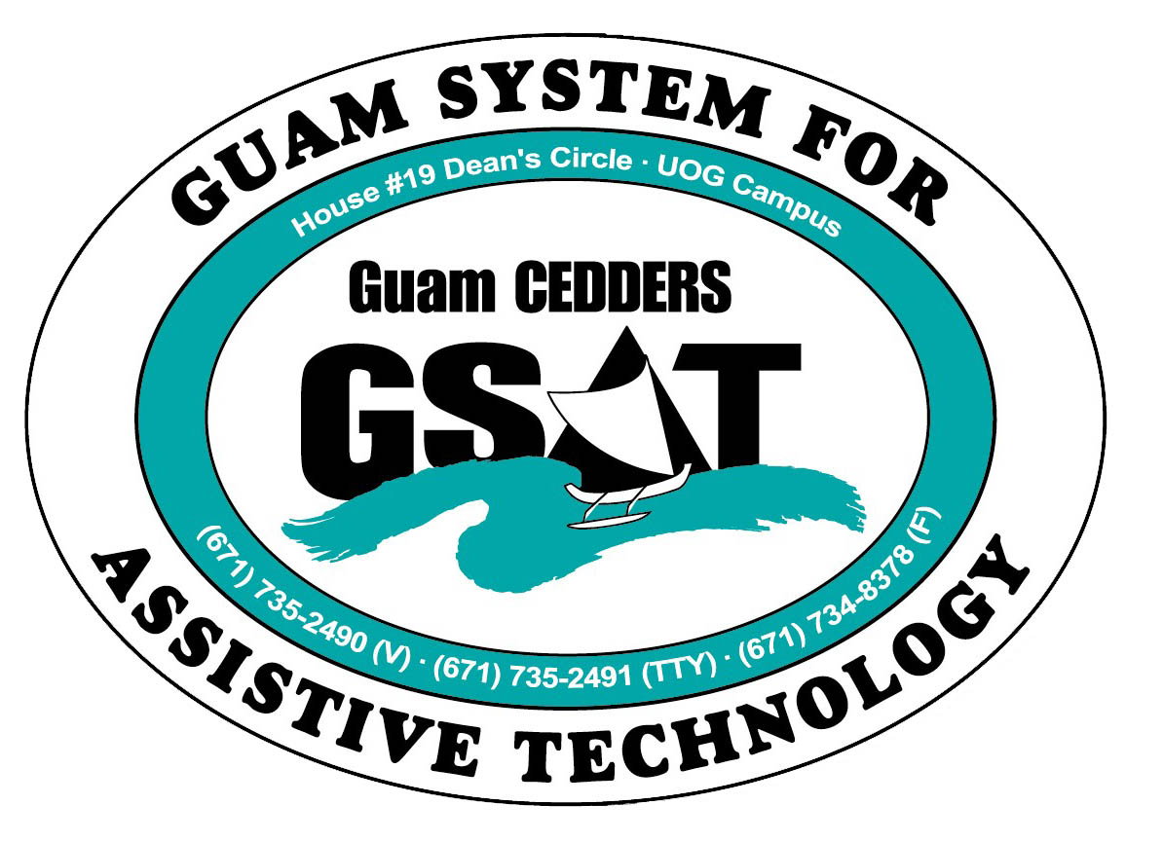

University of Guam CEDDERS

Guam System for Assistive Technology

Advisory Council

General Membership Meeting

Tuesday, January 19, 2016, 3:30-5:00pm

House 19 Deans Circle, UOG
( ) Barbara Johnson, Chairperson |  | ( ) Josephine Cortez |  | ( ) Carla Torres (GSAT)
( ) Rudy Ignacio, Vice-Chairperson |  | ( ) Evelyn Duenas |  | ( ) Carol Cabiles (GLSC)
( ) Dawn Maka, Secretary |  | ( ) Lee Perez |  | ( ) Roseanne Ada (GDDC)
( ) Lisa Ogo, Member At Large |  |  |  | ( ) Ben Servino (DISID DVR/DSS)
( ) Roy Rosario, Member At Large |  |  |  | ( ) Paula Ulloa (GDOE)
( ) Lou Mesa, Member-at-Large |  |  |  | ( ) Karen Taitano Primacio (DOL AJC, WIA)

  - AGENDA
- Call to Order / Introductions

- Review & Approval of Minutes: October 27, 2015

- Revision of Bylaws- Sections I, II, III only

- Reports:
- 2015 Annual Report update
- Quarterly Data: Oct.1-Dec.31, 2015
- 2015 Conference/ Fair Committee Report

- Open Discussion/ Announcements

- Adjournment
Next Meeting April 19, 2016, 3:30-5:00PM

