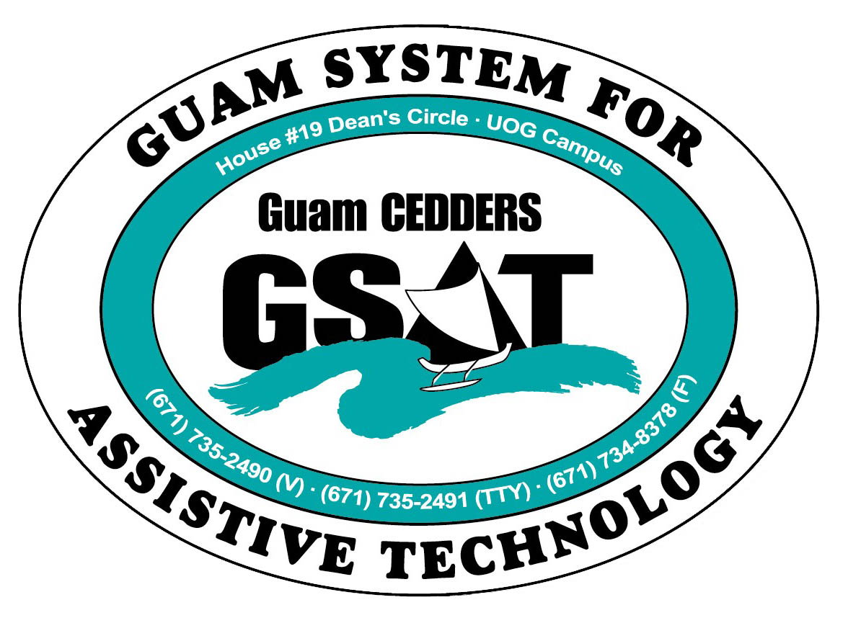

University of Guam CEDDERS

Guam System for Assistive Technology

Advisory Council

General Membership Meeting

Tuesday, January 19, 2016, 3:30-5:00pm

House 19 Deans Circle, UOG
(X) Barbara Johnson, Chairperson |  | (X) Josephine Cortez |  | (X) Carla Torres (GSAT)
( ) Rudy Ignacio, Vice-Chairperson | ( ) Evelyn Duenas |  |  | (X) Carol Cabiles (GLSC)
(X) Dawn Maka, Secretary |  | (X) Lee Perez |  | (X) Roseanne Ada (GDDC)
( ) Lisa Ogo, Member At Large |  |  |  | (X) Ben Servino (DISID DVR/DSS)
( ) Roy Rosario, Member At Large |  |  |  | (X) Paula Ulloa (GDOE)
( X) Lou Mesa, Member-at-Large |  |  |  | (X) Karen Taitano Primacio (DOL AJC, WIA)
 |  |  | (X) Jeannie Hollis

  - Minutes
- Call to Order / Introductions
Carla Torres called the meeting to order at 3:41PM, followed by introduction of members.
- Review & Approval of Minutes: October 27, 2015
Lou Mesa makes a motion to approve the October 27 minutes. Dawn Maka seconds the motion. Approved by Acclamation
- Revision of Bylaws- Sections I, II, III only
The GSAT executive committee reviewed and drafted revisions to Sections I-III of the Bylaws. These revisions were presented to the Council for input. The council had a discussion over them, made some revisions and approved sections I-III. Council goal: complete updated set of bylaws by the end of this fiscal year.
Main changes to the bylaws:
- Change the font from a Serif font to San Serif font to increase readability
- Change from AT “project” to AT “program”
- Change Guam Public School System (GPSS) to Guam Department of Education (GDOE)
- Change Department of Labor to Department of Labor, American Job Center
- Restructure the presentation of the content, move definitions to the end
- Get rid of the word “consumer” and use “Individuals with Disabilities and Family Members of the Individuals that uses Assistive Technology.” Note: The AT grant still uses the term “Consumer.”
- Restate or redefine the purpose of the Council. Target specific disability groups- add senior and transition ages to be more comprehensive in the approach to providing services
- Amend the composition of the Council
- Add the 3 members-at-large to the list of officers
- Remove the public forum mandate, which is not stipulated in the AT grant
- Change the public notice of the meeting to posting on GSAT’s website
- Process to which members are removed
- Reports:
- 2015 Annual Report update
There is still no official mechanism for submitting an annual AT report to the US Department of Health and Human Services – Administration for Community Living. Their management information system is not developed yet. Carla said she submitted report that’s not official into ATAP’s NATADS system as directed by the AT grant administrator.
- Quarterly Data: Oct.1-Dec.31, 2015 (copies disseminated).
2 GOAL-AT loan applications were approved . Paula asked what happens if applications are incomplete. Carla said the individuals are provided with the assistance and added that sometimes individuals change their minds after loans are approved. Carla will provide GOAL-AT brochures and email Paula information on the loan program. She briefly explains the loan program and shares that GSAT is in the process of reviewing an application for an accessible vehicle. The referral came from Ben. Client is thinking of running a shuttle service with his van and charging only $10- $15 as opposed to $50 / $100 people have to pay now. Lee Perez added that for disabled vets if they meet a certain percentage of disability, they can get up to $15,000 from Veterans Affairs for an accessible vehicle.
- 2015 Conference/ Fair Committee Report (minutes from the last two meetings disseminated) An email was sent to the Council for the change in date and time. Carla thanked the Co-Sponsors GLSC-DLC, who committed $1000 to the venue costs, DVR and GDDC has both committed one print ad. Carla wanted to discuss the theme and get input from the general membership (theme ideas generated by the committee were included in the packet that was disseminated). Carla selected: “Promoting and Protecting Access to Assistive Technology through Transitions”. “Promoting and Protecting” was derived from the NCART – National Complex and Rehab Technology motto. A certain percentage of the AT grant has to be used towards transition activities. Carla said Assistive Technology (AT) can help with transitions and this will be the focus of the conference. Lee Perez said the theme needs to be a little more understandable. Carla explains the Workforce Innovation and Opportunity Act (WIOA) and the drafted agenda.
Theme Ideas from the General Membership:
- “Workforce and Innovation Opportunities through AT”
- Driving Innovations in the Workforce
- Assistive Technology: Innovations and Opportunities in the Workplace,”
- Assistive Technology: Creating Innovations in the Workforce
- 22nd Annual GSAT Assistive Technology Conference: Creating Innovations in the Transition to the Workforce
- 22nd Annual GSAT Assistive Technology Conference: Creating Innovations to Transition into the Workforce
- 22nd Annual Guam System for Assistive Technology (GSAT) Conference.
- Transitioning Creative Innovations in the Workforce
- Creating Innovations in the Transition to Work

The next Conference and Fair planning committee meeting is scheduled for February 9, but may be earlier to finalize things.

- Open Discussion/ Announcements
- Mrs. Ada announced that there’s a new executive director at Guma’mami , Sam Illesugam
- Paula Ulloa stated the an Education Interpreter(EI) Position in DOE was created. The board is meeting tomorrow, January 20, 2016, at Benavente Middle School in Dededo, from 6-8PM .
- Adjournment
Dawn moved to adjourn the meeting, Carol Cabiles seconded the motion. Meeting adjourned at 5:04PM.

Next Meeting April 19, 2016, 3:30-5:00PM

