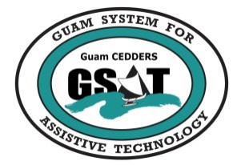

Guam System for Assistive Technology (GSAT)
Conference & Fair Planning Committee Meeting
Tuesday, January 12, 2016 ~ 2:00PM – 3:30PM
  - Committee Members:
( ) Barbara Johnson, Chairperson | ( ) Carla Torres, GSAT program coordinator
( ) Rudy Ignacio, Vice Chairperson | ( ) Jennifer Vicente, GLSC-DLC
( ) Lou Mesa, Member at Large | ( ) Raymond Sayas, GDDC
( ) Lisa Ogo, Member at Large | ( ) Nichol T. Napoleon, GDOE
( ) Roy Rosario, Member at Large | ( ) Ben Servino, DISID/DVR/DSS
( ) Josephine Cortez | ( ) Karen Taitano Primacio, AHRD/GDOL
( ) Evelyn Duenas | ( ) Monica Duenas, ASL Interpreter

Agenda
- Call to order/ Introductions
- Review/ Approval of minutes
- Conference
- Date
- Location
- Co-sponsorship
- Agenda
- Theme/ Title
- Fair
- Date
- Vendor Invite List
- Entertainment
- Timeline for Conference & Fair
- Invitations
- Advertising
- Registration

