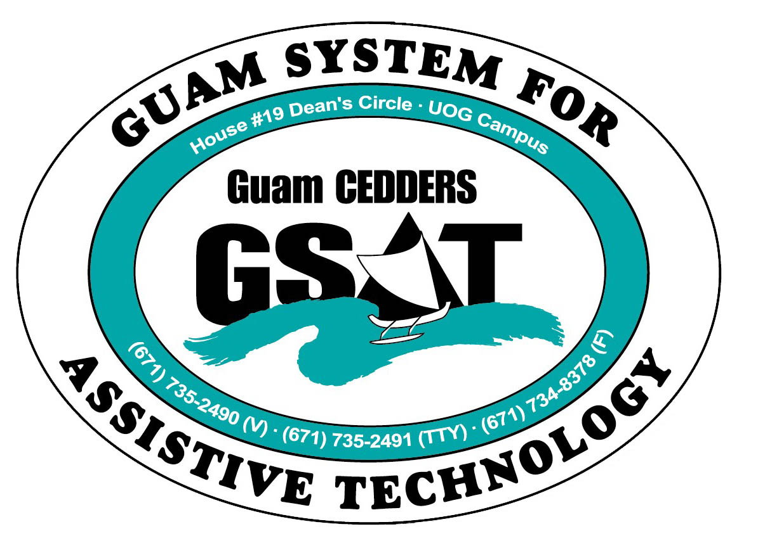

University of Guam CEDDERS

Guam System for Assistive Technology

Advisory Council

General Membership Meeting

Tuesday, June 14, 2016, 3:30-5:00pm

House 19 Deans Circle, UOG
( ) Barbara Johnson, Chairperson |  | ( ) Josephine Cortez |  | ( ) Carla Torres (GSAT)
( ) Rudy Ignacio, Vice-Chairperson |  | ( ) Evelyn Duenas |  | ( ) Jennifer Vicente (GLSC-DLC)
( ) Dawn Maka, Secretary |  | ( ) Lee Perez |  | ( ) Roseanne Ada (GDDC)
( ) Lisa Ogo, Member At Large |  |  |  | ( ) Ben Servino (DISID DVR/DSS)
( ) Roy Rosario, Member At Large |  |  |  | ( ) Nichol Napoleon (GDOE)
( ) Lou Mesa, Member-at-Large |  |  |  | ( ) Karen Taitano Primacio (DOL AJC, WIA)

  - AGENDA
- Call to Order / Introductions

- Review & Approval of Minutes April 19, 2016

- State Plan Update

- Conference/Fair Committee Sign-up

- Quarterly Data Report: April.1-May.31, 2016

- Open Discussion/ Announcement

- Adjournment

Next Meeting: October 18, 2016 3:30-5:00PM

