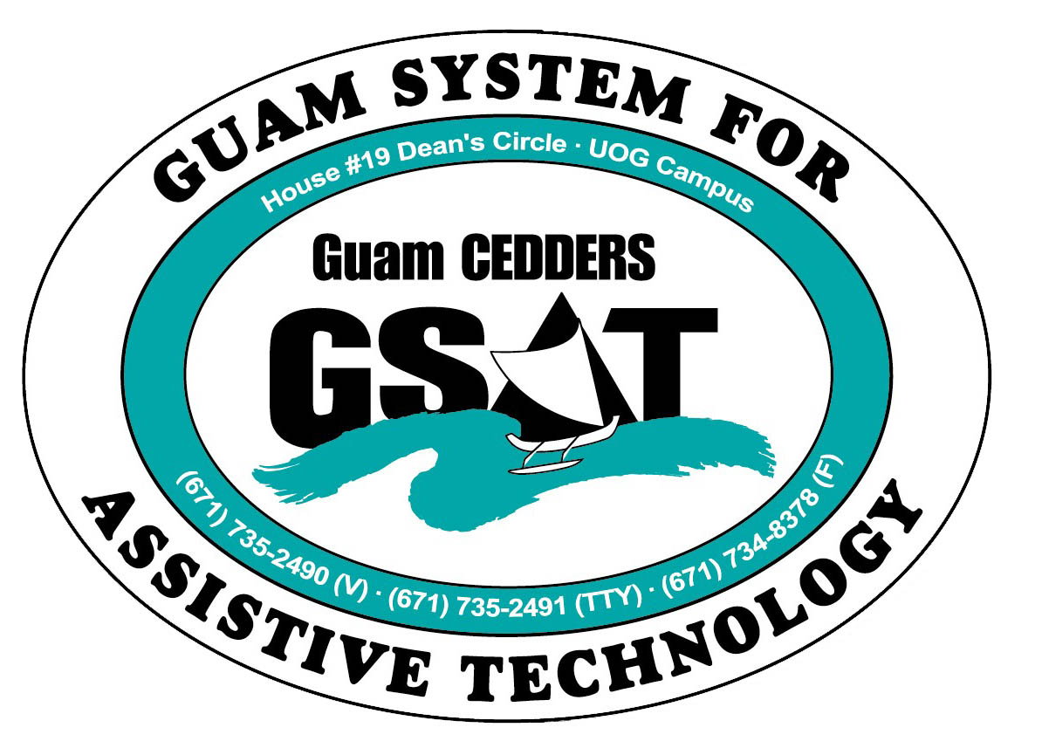

University of Guam CEDDERS

Guam System for Assistive Technology

Advisory Council

General Membership Meeting

Tuesday, June 14, 2016, 3:30-5:00pm

House 19 Deans Circle, UOG
(X) Barbara Johnson, Chairperson | (X) Josephine Cortez | (X) Carla Torres (GSAT)
(X) Rudy Ignacio, Vice-Chairperson | (X) Evelyn Duenas | (X)Carol Cabiles (GLSC)
(X) Dawn Maka, Secretary | ( ) Lee Perez | (X) Raymond Sayas (GDDC)
( ) Lisa Ogo, Member At Large |  | (X) Ben Servino (DISID DVR/DSS)
( ) Roy Rosario, Member At Large |  | ( ) Nicole Napoleon (GDOE)
(X) Lou Mesa, Member-at-Large |  | (X) Karen Taitano Primacio (DOL AJC, WIA)  (X ) Terrie Fejarang (CEDDERS)  (X) Evangelis Babauta (ASL Interpreter)

  - Minutes
- Call to Order / Introductions. Rudy called the meeting to order at 3:50PM. Carla Torres extended a thank you to the council for the personal time and dedication put into the AT conference and fair and ensuring that the AT needs are met for people in Guam. Terrie Fejarang mentioned that she met with Heidi to talk about how GSAT can evolve. She acknowledged the great work that Carla has facilitated since 2008. She expressed that there have been a lot of things accomplished. Terrie Fejarang shared that Carla has also worked as faculty in the LEND program. She stressed the importance of sustainability. CEDDERS employees are limited term and based on the availability of funds. Discussion was made on the possibility that the program can move and it’s the governor that decides which agency handles the GSAT grant. Terrie shares with the Council the progression of GSAT coordinators. She mentioned that there will be times when GSAT will be closed for the summer. Leah has been selected for Jury service and going on leave in July. Carla said that the center is closed on Fridays to appointments only but have been getting a lot of folks coming. Ben Servino commends Carla for her accomplishments, he added that she was the first person that’s received an Asssitive Technology Professional Certification (ATP). He said that DISID has a major role in looking at sustainability, their federal funding won’t last for long. He announced to the council that he will be running for senator. He further stated that they need someone in the legislature to advocate for people with disabilities, the youth and their families.

- Review & Approval of Minutes. Lou Mesa approved the minutes on April 19, 2016, Dawn Maka seconds the motion. Approved by acclamation. The motion was carried.

- State Plan Updates. Carla shared with the Council that there was a request for an update and as far as GSAT’s state plan there was no changes except for the composition of the Advisory Council. Last general membership meeting the council amended and updated the Bylaws to reduce the number of individuals. From 17 members, it was reduced to 7 to 11 members.

- Conference/Fair Committee Sign-up.
Carla asked the Council of anyone interested in being a part of the Conference/Fair Committee to plan for AT Conference and Fair in 2017. The following individuals have signed up:
- Josephine Cortez 3. Ben Servino
- Evelyn Duenas 4. Lou Mesa

- Quarterly Data Report: April.1-May.31, 2016 (included in the packet)
Carla stated that loan applications are coming in. She is meeting with an applicant on Friday. It will be the 8th loan for this year

- Open Discussion/ Announcement
- Ben Servino announced that the ADA Conference will be on July 5. There will be a series of workshops for businesses on how to make their parking spaces accessible. DISID will be requesting the assistance of Guam Legal Services to do workshops in the provision of reasonable accommodations according to Title I of the ADA, the rights of the individuals under the ADA, and voting accessibility. SiNA will be doing evaluations for businesses that are compliant with ADA . Ben has asked the Coordinators from the Government agencies to write an article on what they’ve done to comply with the ADA as far as program access. Ben said he will be attending an ADA Conference in San Francisco in July 25-26. He has also been communicating with someone in the states that does a forum on ADA. They said they can come to Guam for 2 days, and just needs support for airfare and lodging in September. Ben will send out the draft agenda. Evelyn asked where to obtain the listing of ADA coordinators. Ben said it will be published in the PDN and The Post.
- Carla announced that Fukuda Enterprises started their accessible taxi services. Rate service is $40 per hour. Fukuda Enterprises is also an authorized vendor for accessible vehicle equipment, i.e. Bruno, chairs in vehicles that come out and lower to the ground, wheelchair hoist in trunks, ramps, etc. Jason Fukuda is going off island soon to be certified, and they also partnered with a company in Hawaii that does accessible transportation
- Adjournment
The meeting was adjourned at 4:33PM

Next Meeting: October 18, 2016 3:30-5:00PM

