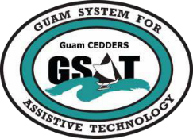
University of Guam CEDDERS — Guam System for Assistive Technology
Advisory Council General Membership Meeting
Tuesday, April 18, 2017; 3:30 – 5:00PM • House 19 Deans Circle, UOG

Rudy Ignacio, Chairperson
Barbara Johnson, Vice-Chairperson
Lou Mesa, Secretary
Dawn Maka, Member-at-Large
Josephine Cortez, Member-at-Large
Evelyn Duenas
Tom Manglona
Victor Tuquero
Jude Ogo
Leah Abelon (GSAT)
Carol Cabiles (GLSC-DLC)
Rosanne Ada (GDDC)
Ben Servino (DISID-DVR, DSS)
Jack Larimer (GDOE)
Phyllis Topasna (AJC, GDOL)
Evangelis Babauta (ASL Interpreter)

AGENDA

Call to Order / Introductions

Review Minutes: January 24, 2017

Old Business
- 2017 AT Conference and Fair Debrief
- Recruitment of Members
- Reports
- Quarterly Report

New Business
- AT Devices to procure
- GSAT Website Update
- Akudi Loan Report
- RESNA Conference /IAAP Access Conference

Open Discussion / Announcements
- GRTA Meeting on April 18
- PEP Disability Conference on April 29, 2017

Adjournment
Next Membership meeting, July 18, 2017, 3:30-5:00PM

