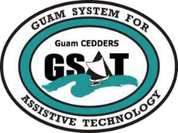

University of Guam — Guam System for Assistive Technology
Advisory Council General Membership Meeting
Tuesday, January 24, 2017; 3:30PM-5:00PM • House 19 Dean’s Circle, UOG

Rudy Ignacio, Chairperson
Barbara Johnson, Vice-Chairperson
Lou Mesa, Secretary
Dawn Maka, Member-at-Large
Josephine Cortez, Member-at-Large
Evelyn Duenas
Tom Manglona
Victor Tuquero
Leah Abelon (GSAT)
Carol Cabiles (GLSC-DLC)
Rosanne Ada (GDDC)
Ben Servino (DISID-DVR, DSS)
Jack Larimer (GDOE)
Phyllis Topasna (AJC, GDOL)
Evangelis Babauta (ASL Interpreter)

AGENDA
- Call to Order / Introductions
- Review Minutes: January 24, 2017
- Old Business
  - 2017 AT Conference and Fair Debrief
  - Recruitment of Members
  - Reports
    - Quarterly Report
- New Business
  - AT Devices to procure
  - Akudi Loan Status
  - RESNA Conference /IAAP Access Conference
- Open Discussion / Announcements
- Adjournment
Next Membership meeting, April 28, 2017, 3:30-5:00PM

