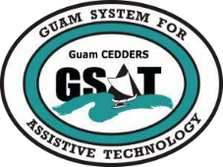
University of Guam CEDDERS—Guam System for Assistive Technology
Advisory Council General Membership Meeting
Tuesday, July 25, 2017; 3:30 – 5:00PM•House 19 Deans Circle, UOG

AGENDA

Call to Order / Introductions

Review Minutes: April 18, 2017

Old Business
  - AT Equipment purchased
  - Messaging app for Council Members
  - Quarterly Report

New Business
- Input for 2018 – 2020 State Plan
- New AT Devices for GSAT Demo and Model Home
- Conference and Fair Planning Committee Sign Up

Open Discussion / Announcements
- Accessible Website Requirements on July 24, 2017 at DISID
- GSAT Model Home Open House on July 28, 2017, House 20 Dean Circle from 9am to 11am
- Special Olympics Bowling, volunteers registration deadline by July 29, 2017
- DISID Bowling, $300 registration per team, free for individuals with disabilities. Team must have at least one IWD
- 18th Annual Creative Spirit Art Exhibit sponsored by Guma Mami on August 18, 6:00-9:00PM at the Hagatna Cathedral Museum
- NDEAM Conference on September 29, 2017, Venue: TBA
- GCC Certificate Program

Adjournment
Next Membership meeting, October 18, 2017 3:30-5:00PM

